WEEK 7
REACT

9. ReactJS-HOL
App.js

import React from 'react';
import './App.css';
import ListofPlayers from './components/ListofPlayers';
import IndianPlayers from './components/IndianPlayers';

function App() {
const flag = true; // Change this to false to toggle views

return (
<div className="App">
<h1>Cricket App</h1>
{flag ? <ListofPlayers /> : <IndianPlayers />}
</div>
);
}

export default App;

IndianPLayer.js
import React from 'react';

const IndianPlayers = () => {
const T20players = ['Virat', 'Rohit', 'Gill'];
const RanjiPlayers = ['Dhoni', 'Pujara', 'Raina'];

// Destructuring
const [odd1, odd2, odd3] = T20players;
const [even1, even2, even3] = RanjiPlayers;

// Merge both arrays
const mergedPlayers = [...T20players, ...RanjiPlayers];

return (
<div>
<h2>Destructured Players</h2>
<p>Odd Team Players: {odd1}, {odd2}, {odd3}</p>
<p>Even Team Players: {even1}, {even2}, {even3}</p>

<h3>Merged Players</h3>
<ul>
{mergedPlayers.map((player, index) => (
<li key={index}>{player}</li>
))}
</ul>
</div>
);
};

export default IndianPlayers;

ListofPlayers.js
import React from 'react';

const ListofPlayers = () => {
const players = [
{ name: 'Virat', score: 90 },
{ name: 'Rohit', score: 60 },
{ name: 'Gill', score: 45 },
{ name: 'Dhoni', score: 100 },
{ name: 'Raina', score: 72 },
{ name: 'Hardik', score: 55 },
{ name: 'Pant', score: 38 },
{ name: 'Jadeja', score: 77 },
{ name: 'Bumrah', score: 30 },
{ name: 'Shami', score: 82 },
{ name: 'Kuldeep', score: 25 },
];

const filtered = players.filter(player => player.score < 70);

return (
<div>
<h2>All Players</h2>
<ul>
{players.map((player, index) => (
<li key={index}>{player.name} - {player.score}</li>
))}
</ul>

<h3>Players with Score &lt; 70</h3>
<ul>
{filtered.map((player, index) => (
<li key={index}>{player.name} - {player.score}</li>
))}
</ul>
</div>
);
};

export default ListofPlayers;

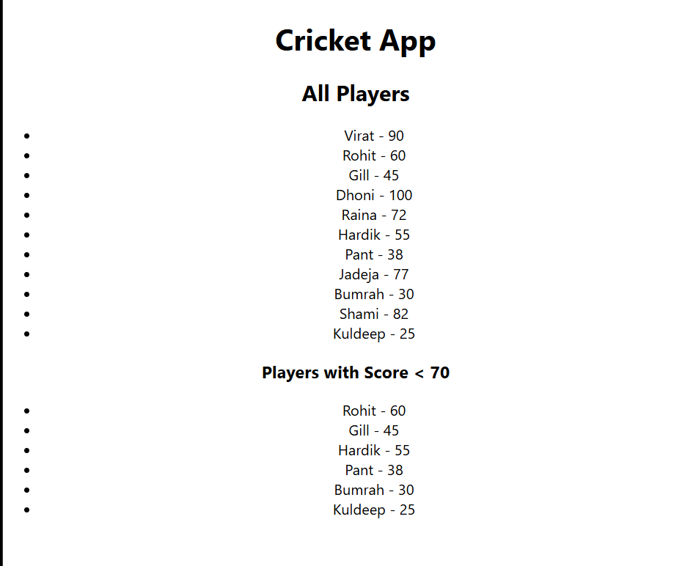

10. ReactJS-HOL
App.js
import React from 'react';
import './App.css';

// Inline style based on rent
const getRentStyle = (rent) => {
return {
color: rent < 60000 ? 'red' : 'green',
fontWeight: 'bold',
};
};

function App() {
const office1 = {
name: 'Tech Park',
rent: 55000,
address: 'Bangalore',
image: 'https://via.placeholder.com/150'
};

const officeSpaces = [
{ name: 'Cyber Hub', rent: 45000, address: 'Gurgaon', image: 'https://via.placeholder.com/150' },
{ name: 'Mindspace', rent: 75000, address: 'Hyderabad', image: 'https://via.placeholder.com/150' },
{ name: 'DLF Towers', rent: 60000, address: 'Delhi', image: 'https://via.placeholder.com/150' }
];

return (
<div className="App">
<h1>🏢 Office Space Rental App</h1>

<h2>Featured Office</h2>
<img src={office1.image} alt={office1.name} />
<p>Name: {office1.name}</p>
<p style={getRentStyle(office1.rent)}>Rent: ₹{office1.rent}</p>
<p>Address: {office1.address}</p>

<hr />

<h2>All Offices</h2>
{officeSpaces.map((office, index) => (
<div key={index} style={{ border: '1px solid black', padding: '10px', margin: '10px' }}>
<img src={office.image} alt={office.name} />
<p>Name: {office.name}</p>
<p style={getRentStyle(office.rent)}>Rent: ₹{office.rent}</p>
<p>Address: {office.address}</p>
</div>
))}
</div>
);
}

export default App;

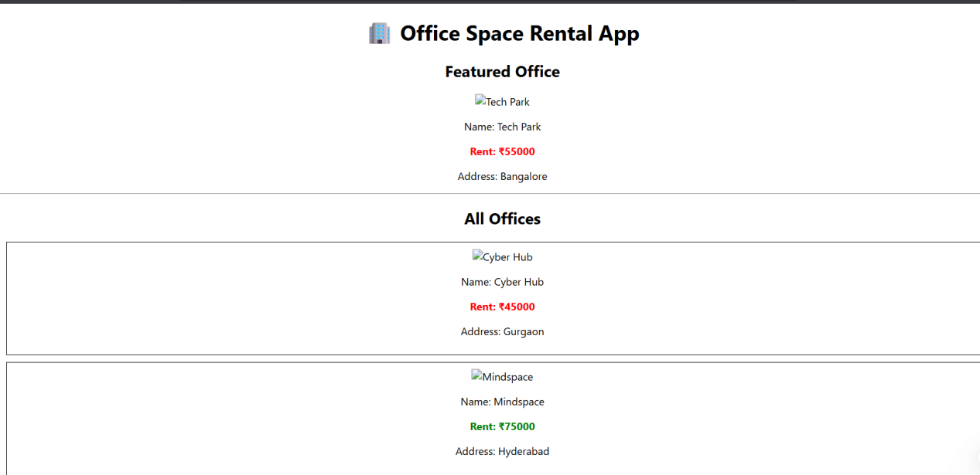

11. ReactJS-HOL
App.js
import React, { Component } from 'react';
import './App.css';

class App extends Component {
constructor() {
super();
this.state = {
count: 0,
message: '',
rupees: '',
euros: '',
};
}

increment = () => {
this.setState({ count: this.state.count + 1 });
this.sayHello();
};

sayHello = () => {
this.setState({ message: 'Hello! This is the increment action.' });
};

decrement = () => {
this.setState({ count: this.state.count - 1 });
};

sayWelcome = (msg) => {
this.setState({ message: msg });
};

handleClick = (e) => {
this.setState({ message: 'I was clicked (Synthetic Event)' });
};

handleConvert = () => {
let euros = parseFloat(this.state.rupees) / 90; // Example rate
this.setState({ euros: euros.toFixed(2) });
};

render() {
return (
<div className="App">
<h1>React Event Handling</h1>

<h2>Counter: {this.state.count}</h2>
<button onClick={this.increment}>Increment</button>
<button onClick={this.decrement}>Decrement</button>

<hr />

<button onClick={() => this.sayWelcome("Welcome to the app!")}>Say Welcome</button>
<button onClick={this.handleClick}>OnPress</button>

<hr />
<h3>Currency Convertor</h3>
<input
type="number"
placeholder="Enter Rupees"
value={this.state.rupees}
onChange={(e) => this.setState({ rupees: e.target.value })}
/>
<button onClick={this.handleConvert}>Convert</button>
<p>Euros: €{this.state.euros}</p>

<hr />
<p><strong>Message:</strong> {this.state.message}</p>
</div>
);
}
}

export default App;

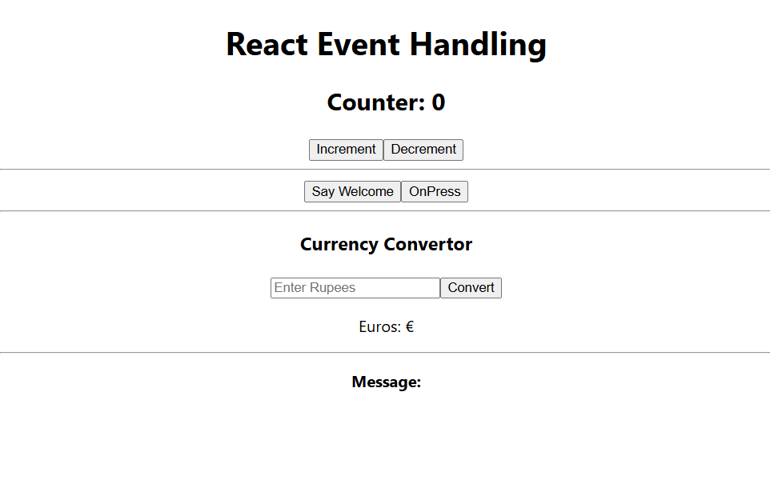

12. ReactJS-HOL
App.js
import React, { useState } from 'react';
import './App.css';

function GuestPage() {
return (
<div>
<h2>Welcome, Guest!</h2>
<p>Browse available flight options below:</p>
<ul>
<li>Flight A - ₹5000</li>
<li>Flight B - ₹6500</li>
<li>Flight C - ₹7200</li>
</ul>
</div>
);
}

function UserPage() {
return (
<div>
<h2>Welcome, User!</h2>
<p>You are now logged in. You can book tickets.</p>
<button>Book Flight A</button>
<button>Book Flight B</button>
</div>
);
}

function App() {
const [loggedIn, setLoggedIn] = useState(false);

const handleLogin = () => setLoggedIn(true);
const handleLogout = () => setLoggedIn(false);

return (
<div className="App">
<h1>✈️ Ticket Booking App</h1>

{loggedIn ? (
<>
<UserPage />
<button onClick={handleLogout}>Logout</button>
</>
) : (
<>
<GuestPage />
<button onClick={handleLogin}>Login</button>
</>
)}
</div>
);
}

export default App;

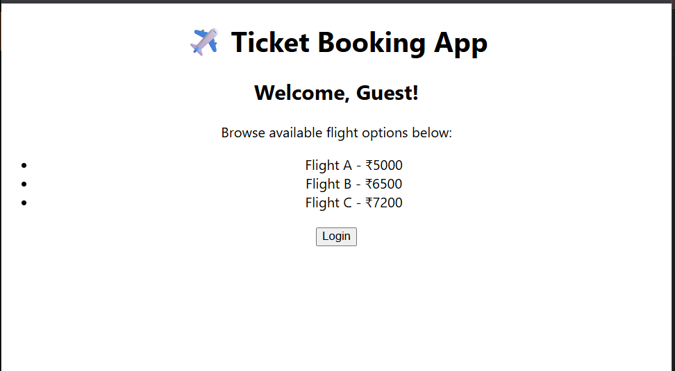

- ReactJS-HOL

App.js
import React, { useState } from 'react';
import './App.css';
import BookDetails from './components/BookDetails';
import BlogDetails from './components/BlogDetails';
import CourseDetails from './components/CourseDetails';

function App() {
const [page, setPage] = useState('book');

return (
<div className="App">
<h1>📝 Blogger App</h1>

<div style={{ marginBottom: '20px' }}>
<button onClick={() => setPage('book')}>Book</button>
<button onClick={() => setPage('blog')}>Blog</button>
<button onClick={() => setPage('course')}>Course</button>
</div>

{/* Conditional Rendering in 3 ways */}
{page === 'book' && <BookDetails />}

{page === 'blog' ? <BlogDetails /> : null}

{(() => {
if (page === 'course') {
return <CourseDetails />;
}
})()}
</div>
);
}

export default App;
BlogDetail.js
import React from 'react';

function BlogDetails() {
return (
<div>
<h2>✍️ Blog Details</h2>
<p>Title: React for Beginners</p>
<p>Category: Web Development</p>
</div>
);
}

export default BlogDetails;
BookDetail.js

import React from 'react';

function BookDetails() {
return (
<div>
<h2>📘 Book Details</h2>
<p>Title: Learn React Easily</p>
<p>Author: John Smith</p>
</div>
);
}

export default BookDetails;
CourseDetail.js
import React from 'react';

function CourseDetails() {
return (
<div>
<h2>🎓 Course Details</h2>
<p>Name: Full Stack Development</p>
<p>Duration: 3 Months</p>
</div>
);
}

export default CourseDetails;

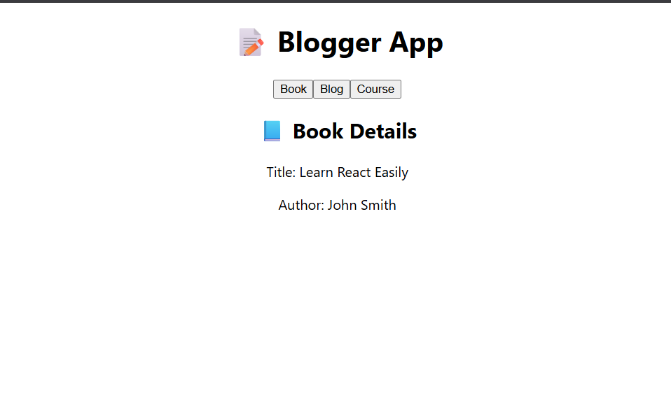
-----------------------------X-------------------X-----------------------

